|  |  |  |  |  |  |
| --- | --- | --- | --- | --- | --- |
| Date | 28-Nov-22 | | | Tester Name | Janette Paus |
| Environment | Penfax - Test 2 | | | Login used |  |
| Operating System | Windows | Version: 21H2 | Update Number: | | |
| Software Used | Edge | Version: 107.0.1418.56 | Update Number: | | |
| Select Software | Version: | Update Number: | | |
| Application Release version | R22.4.1 | | | | |
| Test Case Title | E 18.4 | | | | |
| Test Type | Regression | | | | |
| Test Scenario | Process a VPB Lump Sum Payment to a Non-Resident | | | | |
| Expected Results | That the payment will process and tax calculation/NR4 and letter generates correctly  Scenario 1: USA Non-Resident (expecting 15% tax, regardless of amount of payment)  Scenario 2: Other Country Non-Resident (expecting tax to match tax tables)  Scenario 3: 100% payout VPB USA Non-Resident (expecting 25% tax, regardless of amount of payment  Payment History shows the correct information on PENWEB | | | | |
| Pass/Fail | Pass | | | JIRA# | N/A |

To find member, complete Person Search for country “United States” and use arrows to find a member of VPB:

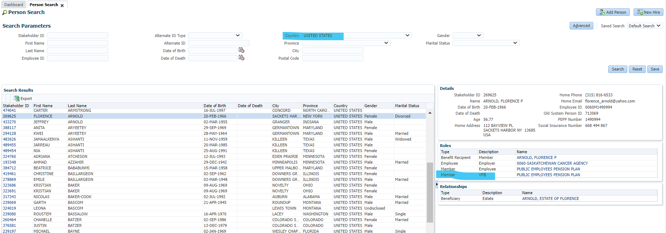

Scenario 1: SID – 269625 – Partial Lump Sum VPB – USA

Confirm member has an account balance greater than zero:

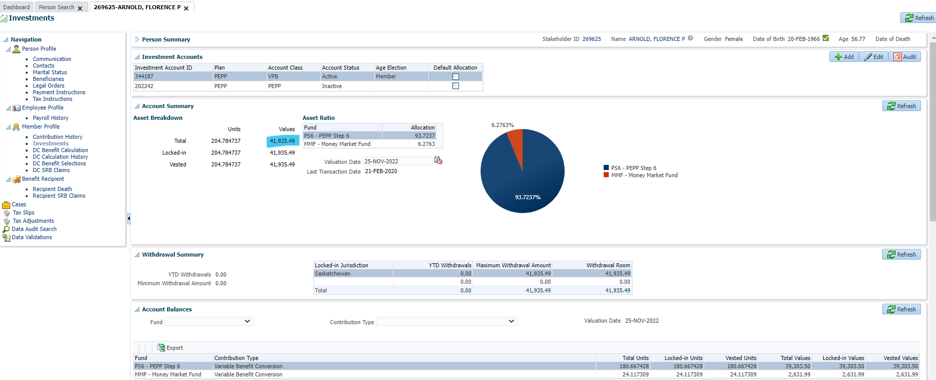

Check if member has scheduled withdrawals – There are none:

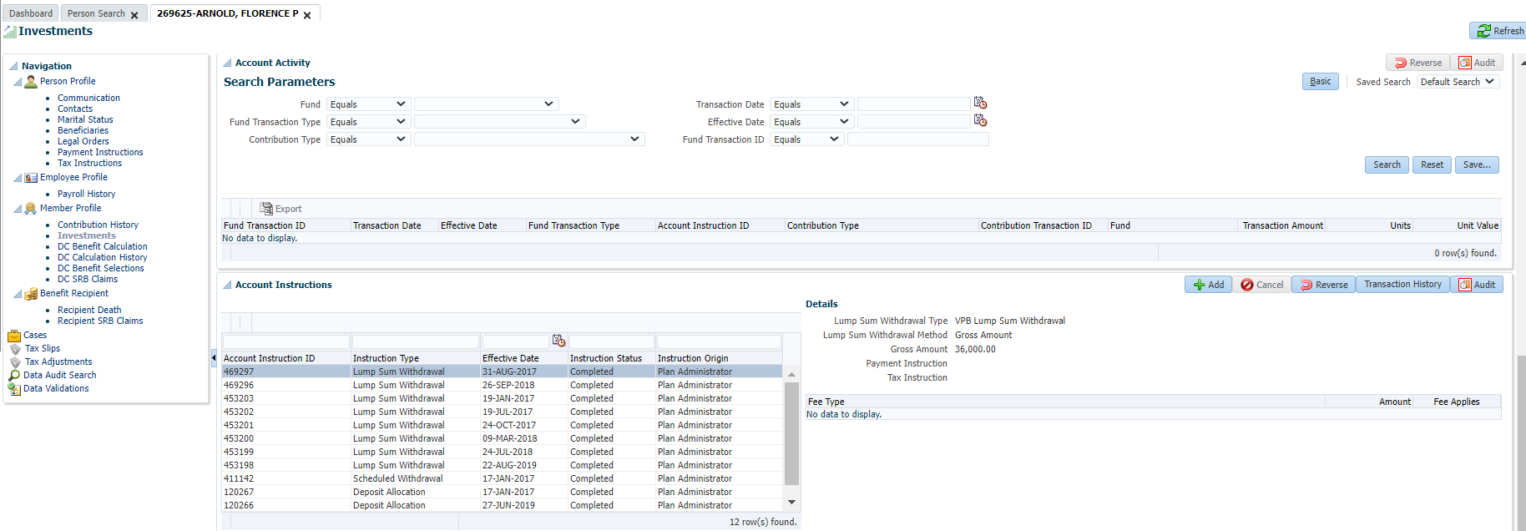

Process a lump sum payment – Click DC Benefit Selection and then click Add: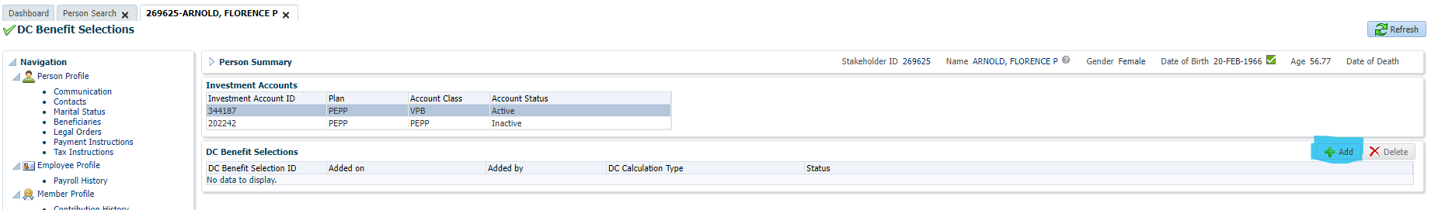

No retirement date required as member is in VPB, click Next:

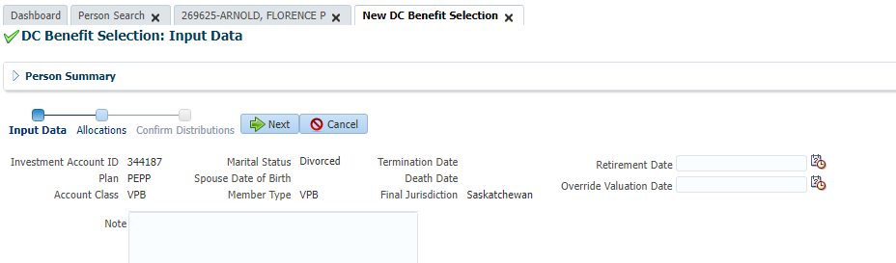

Click Add:

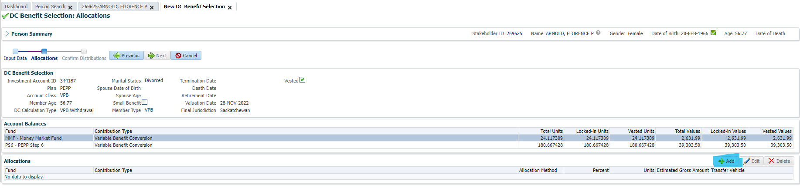

Enter payment details and click Save:

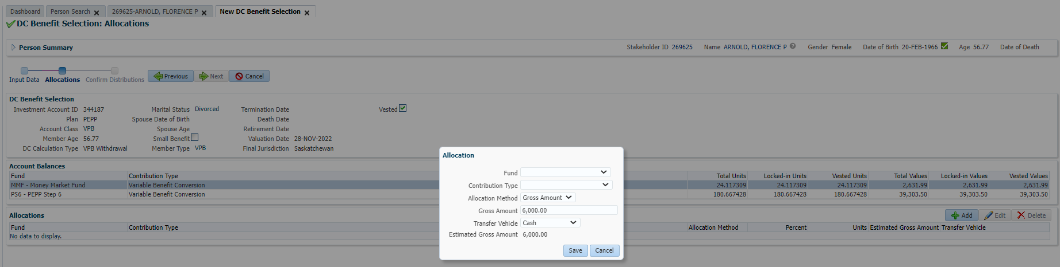

Click Next:

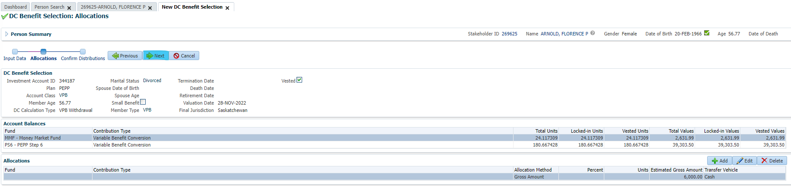

If there are no Payment Instructions, add a new one. Then add Tax Instruction (change the Taxation Country to USA):

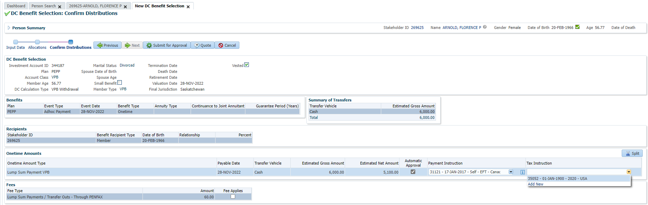

Click Submit for Approval and then Approve:

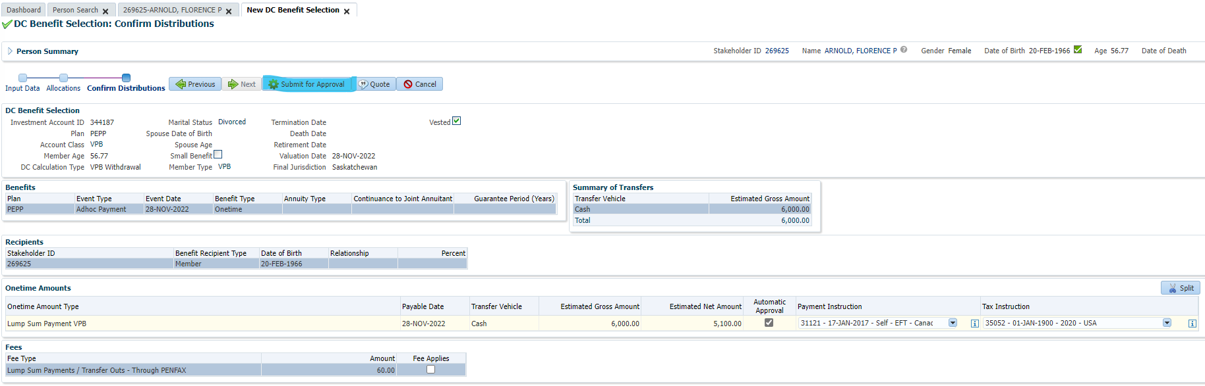

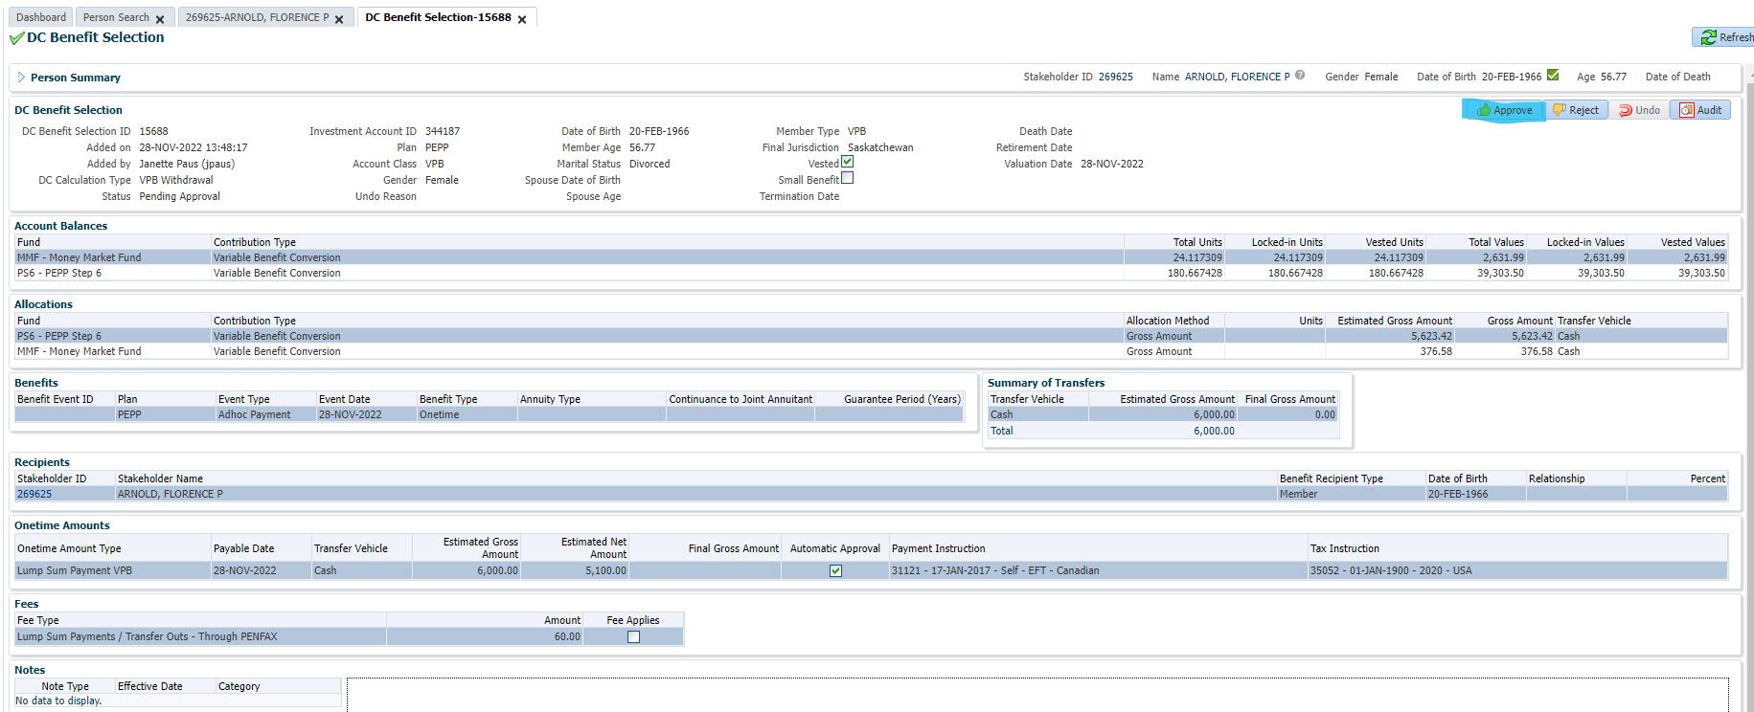

Confirm payment has processed correctly after PIT has run:

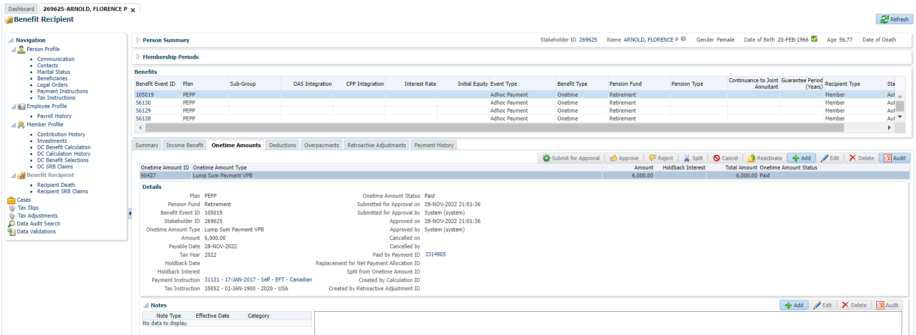

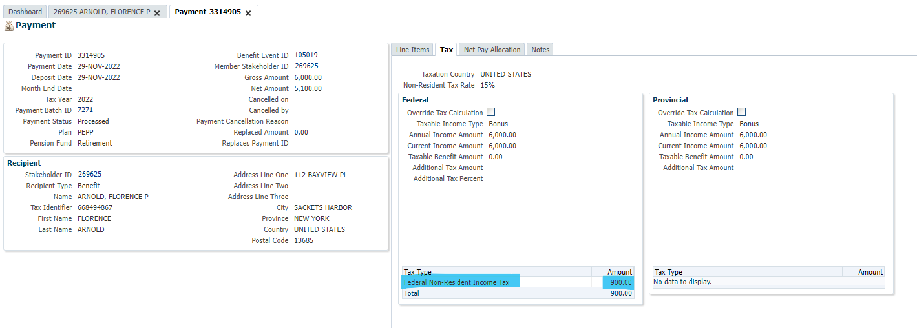

Scenario 2: SID 252847 Hong Kong Lump Sum Partial payment – net amount

Scheduled payment/partial rate:

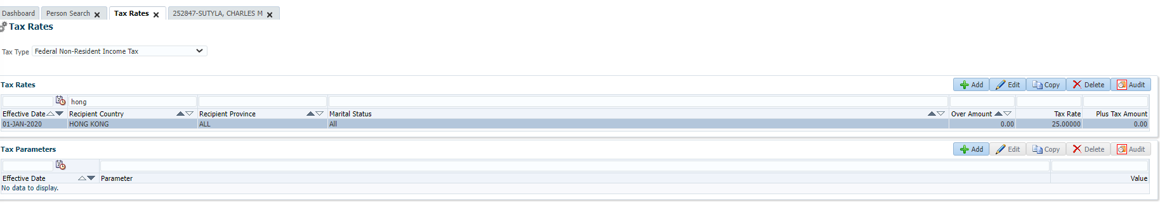

100% payout Tax Rate:

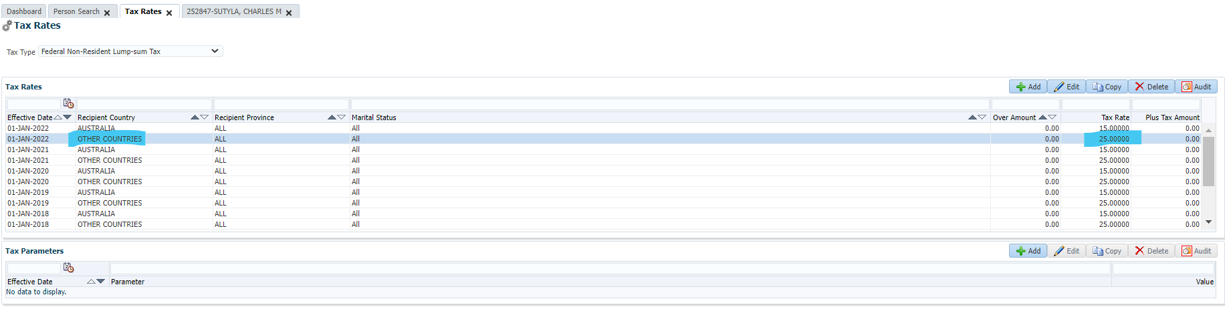

Lump Sum payment $20k NET:

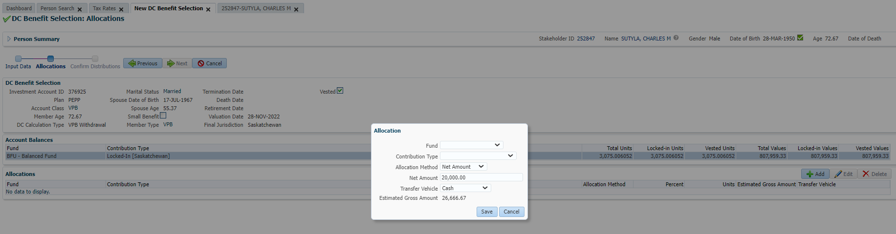

Add Tax Instructions to payment, click Submit for Approval:

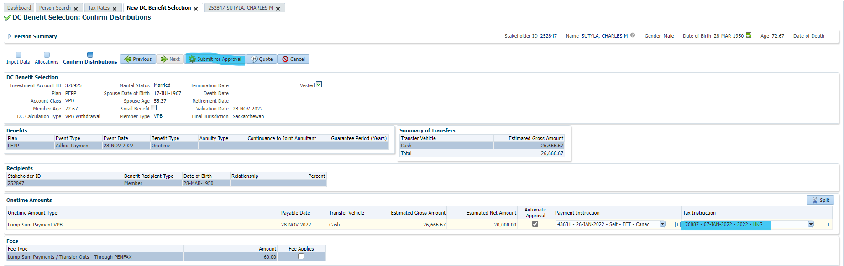

Click Approve:

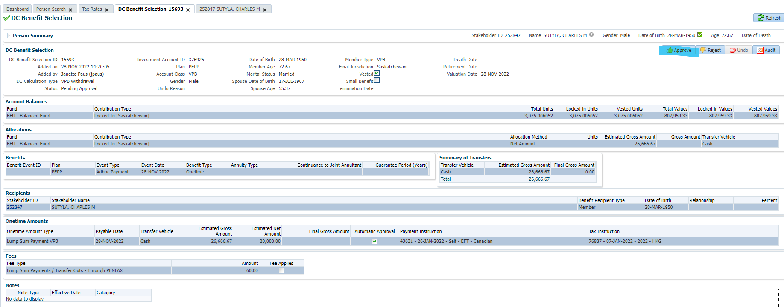

Confirm payment has processed correctly after PIT has run:

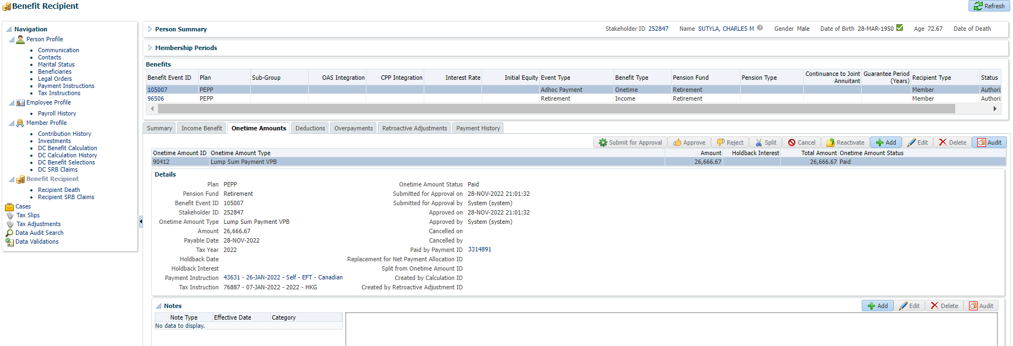

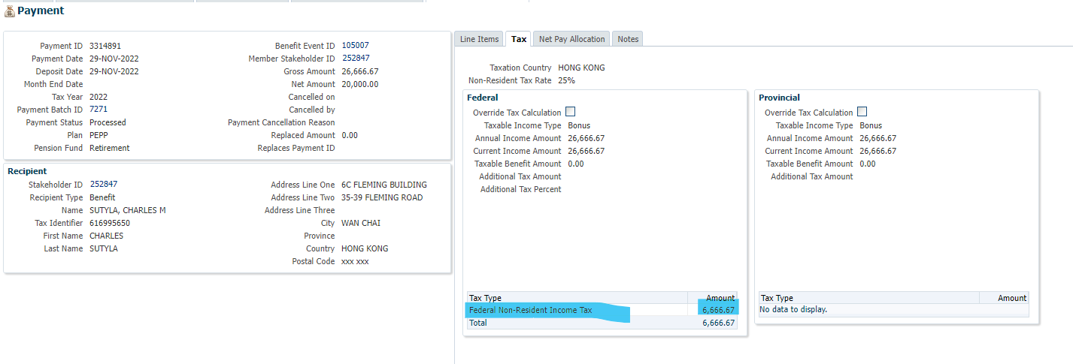

Scenario 3: SID 278869 USA Lump Sum 100% payout

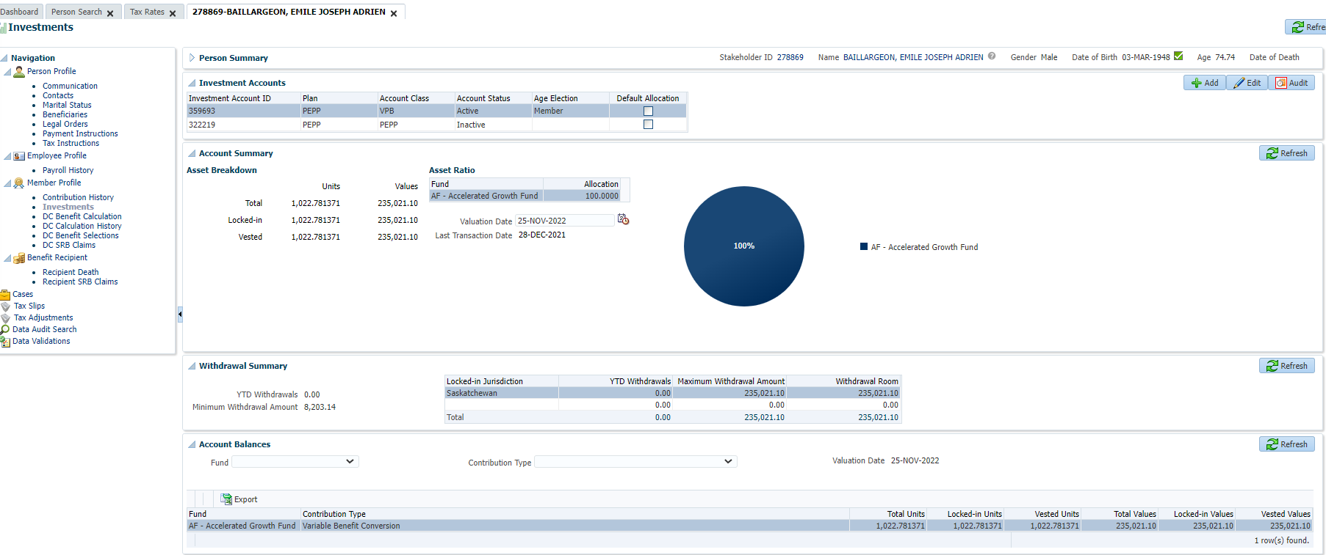

Add Lump Sum payment, click Save:

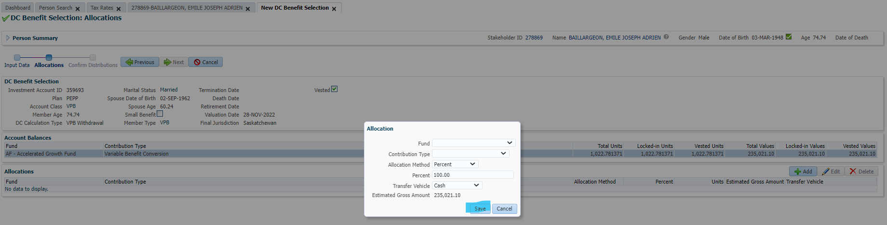

Click Next:

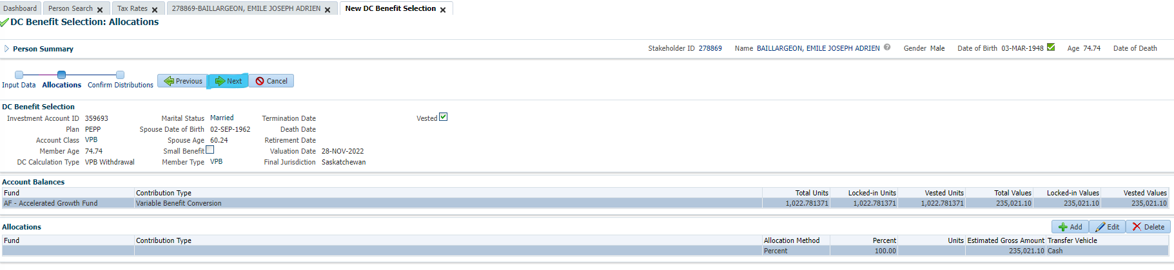

Add Tax Instructions to payment:

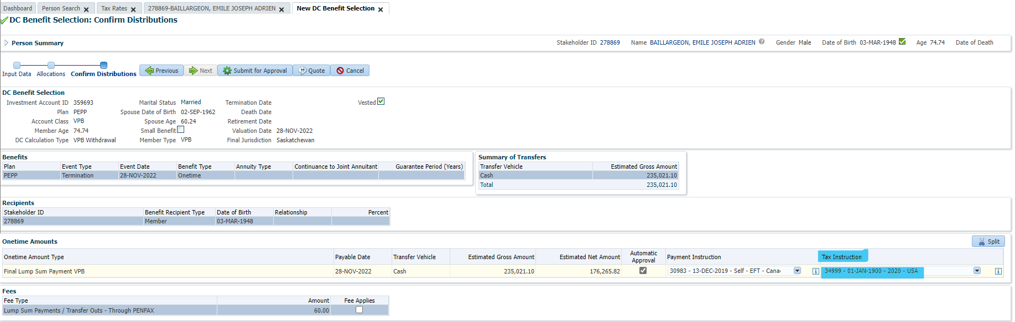

Click Submit for Approval:

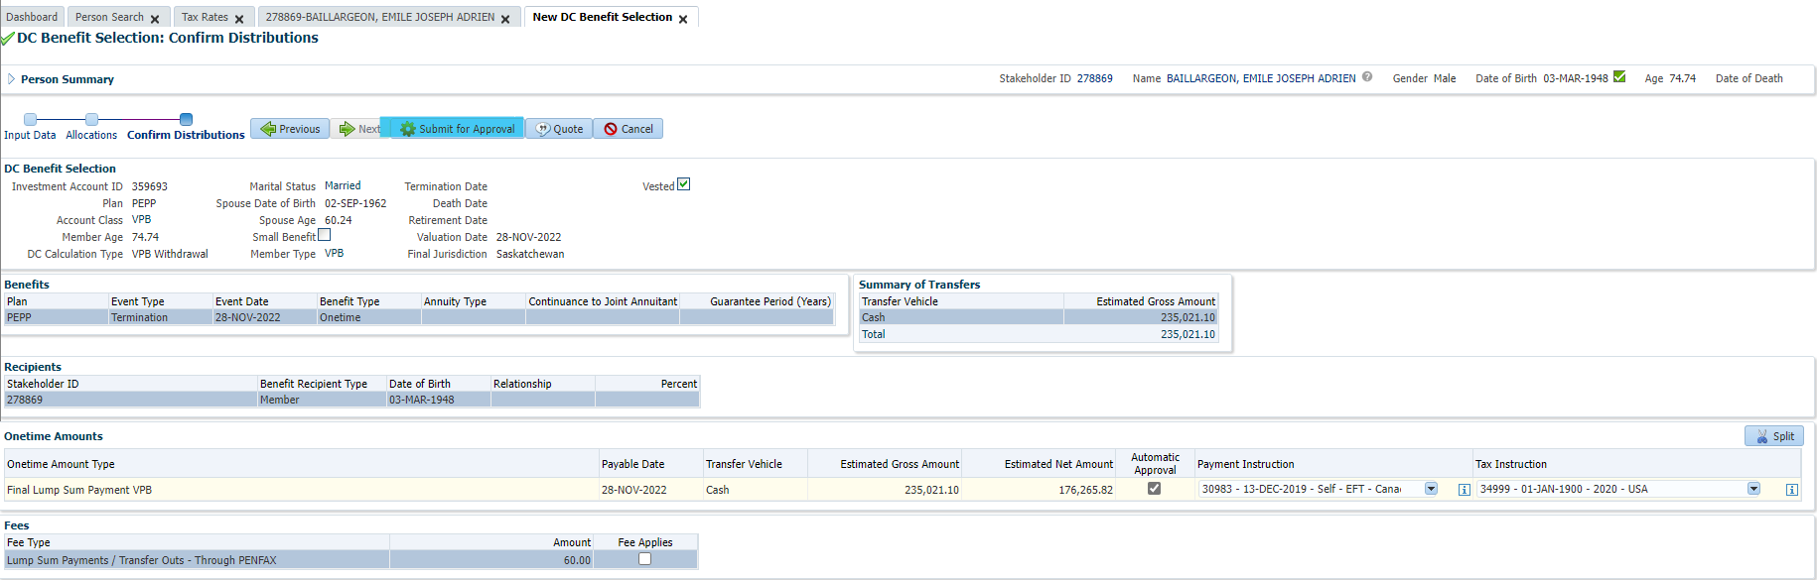

Click Approve:

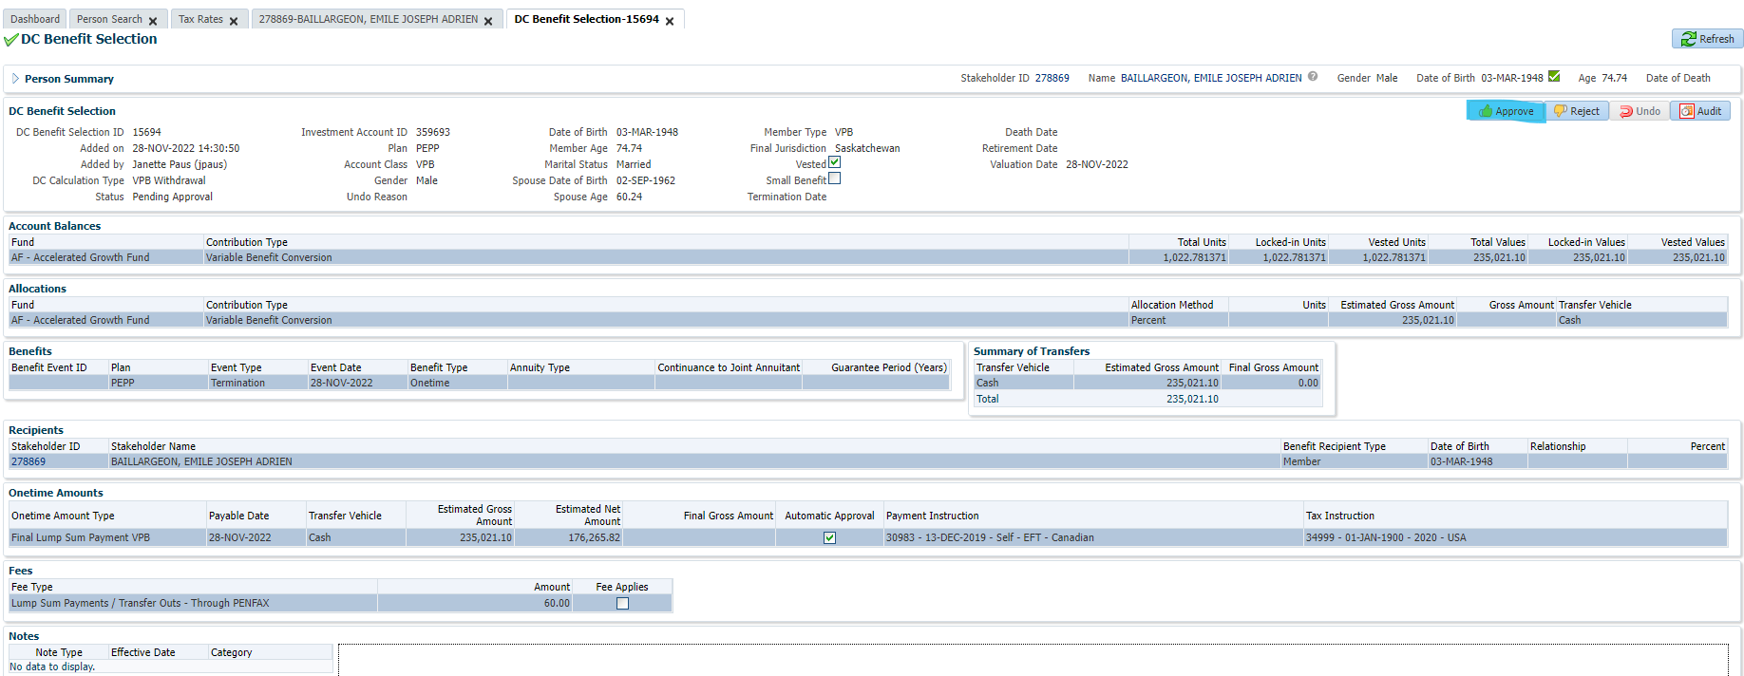

Next day after PIT runs, confirm results:

